**Spring 2019 Iterators and Generators Review**

Problem 1: WWPD

|  |  |
| --- | --- |
|  |  |

Problem 2: WWPD Again!

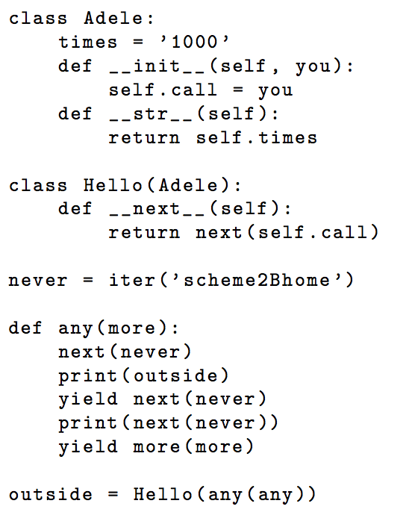

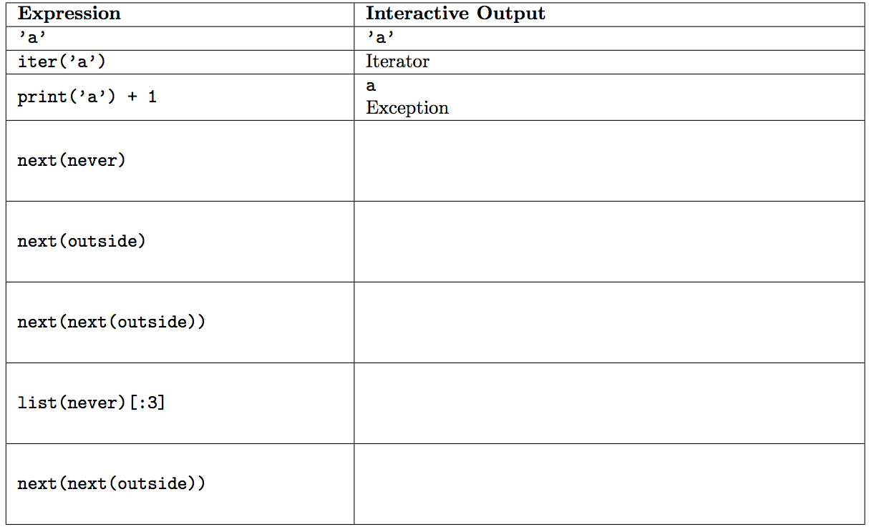

Question 3: Skip Machine

|  |  |
| --- | --- |
|  |  |

Question 4: Unique

